Supplementary material
One Year Health-Related Quality of Life after Discharge: A Prospective Cohort Study Among COVID-19 ICU Survivors.

Index | Page 1
Supplementary Table 1. Indications for transfer of patients with COVID-19 to intensive care unit (ICU). | Page 2
Supplementary Table 2. Laboratory parameters at the time of ICU admission in patients with normal/reduced health-related quality of life 1 year after discharge . | Page 3
Supplementary Table 3. Drugs used in ICU and their prescription schemes. | Page 4
Supplementary Table 4. The incidence of ICU complications in patients with normal/reduced health-related quality of life 1 year after discharge. | Page 5
Charlson Comorbidity Index | Page 6
SF-36 scale and questionnaire for assessing health-related quality of life in COVID-19 patients | Page 7
Supplementary References | Page 10

Supplementary Table 1. Indications for transfer of adult patients with COVID-19 to ICU.
1.Rapidly progressing acute respiratory failure (increasing and severe shortness of breath; cyanosis; respiratory rate >30/min; SpO₂ <90% during oxygen therapy)
2.Systolic arterial pressure <90 mmHg
3.Shock (marbling of the extremities, acrocyanosis, cold extremities, a symptom of a delayed vascular spot (>3 s), lactate >3 mmol/L)
4. Central nervous system dysfunction (score on the Glasgow coma scale <15 points)
5.Acute renal failure (diuresis <0.5 mL/kg/h for 6–12 hours or an increase in creatinine levels twice from the normal value)
6.Thrombocytopenia (number of platelets <100,000/μL or a decrease of 50% from the highest value within a 3 days period)

Supplementary Table 2. Laboratory parameters at the time of ICU admission in patients with normal/reduced health-related quality of life 1 year after discharge.

Parameter | Patients with a reduced physical health  N = 62 | Patients with a normal physical health  N = 41 | p-value, physical health | Patients with a reduced mental health  N = 36 | Patients with a normal mental health  N = 67 | p-value, mental health
Serum Creatinine μmol/L | 85  (IQR: 76–102) | 93  (IQR: 77–106) | 0.3 | 87  (IQR: 79–102) | 90  (IQR: 76–103) | 0.9
*CCª, mL/min | 97  (IQR: 75–115) | 108  (IQR: 73–136) | 0.3 | 103  (IQR: 66–140) | 101  (IQR: 74–115) | 0.7
INR^{b} | 1.2  (IQR: 1.1–1.4) | 1.3  (IQR: 1.2–1.4) | 0.2 | 1.3  (IQR: 1.1–1.3) | 1.3  (IQR: 1.2–1.4) | 0.4
CRP^{c}, mg/L | 112  (IQR: 56–195) | 139  (IQR: 70–189) | 0.7 | 108  (IQR: 54–196) | 137  (IQR: 70–193) | 0.4
LDH^{d}, U/L | 375  (IQR: 305–608) | 496  (IQR: 338–477) | 0.2 | 364  (IQR: 305–543) | 473  (IQR: 317–626) | 0.1
ALT^{e}, IU/L | 40  (IQR: 25–62) | 42  (IQR: 28–72) | 0.7 | 39  (IQR: 28–61) | 41  (IQR: 27–65) | 0.9
AST^{f}, IU/L | 55  (IQR: 39–78) | 62  (IQR: 37–86) | 0.6 | 53  (IQR: 33–83) | 59  (IQR: 39–82) | 0.4
CK^{g}, IU/L | 165  (IQR: 97–297) | 234  (IQR: 101–600) | 0.09 | 181  (IQR: 75–533) | 186  (IQR: 118–360) | 0.7
*D-dimer, ng/mL | 488  (IQR: 288–761) | 379  (IQR: 298–614) | 0.7 | 488  (IQR: 282–925) | 395  (IQR: 293–678) | 0.9
*missing values >10%
Abbreviations: ªcreatinine clearance (Cockcroft-Gault evaluation), ^{b}international normalized ratio, ^{c}c-reactive protein, ^{d}lactate dehydrogenase, ^{e}alanine transaminase, ^{f}aspartate transaminase, ^{g}creatine kinase.

Supplementary Table 3. Drugs used in ICU and their prescription schemes.
Medication | Prescribing scheme
Enoxaparin (low-molecular-weight Heparin) | Subcutaneously. Prophylactic doses—4000 anti-Xa IU (40 mg) 1 time/day. Intermediate—4000 anti-Xa ME (40 mg) 2 times/day; an increase up to 50 IU (0.5 mg)/kg 2 times/day is possible. Therapeutic—subcutaneously 100 anti-Xa ME (1 mg)/kg 2 times/day, with creatinine clearance 15–30 mL/min 100 anti-Xa ME (1 mg)/kg 1 time/day.
Unfractionated Heparin | Subcutaneously or intravenously. Prophylactic doses—subcutaneously 5000 IU 2–3 times/day. Intermediate—subcutaneously 7500 IU 2–3 times/day.  Therapeutic—intravenous infusion is optimally controlled by activated partial thromboplastin time (APTT), maintained at a level of 55–75 s. The initial dose for venous thromboembolic complications is intravenous bolus of 80 U/kg (maximum 5000 U) and infusion with an initial rate of 18 U/kg/h.
Tocilizumab (IL-6 blocker) | 4–8 mg/k/administration in combination with glucocorticosteroids. 400 mg was diluted in 100 ml of 0.9% NaCl solution at room temperature, injected intravenously over 60 minutes in the absence of infusion of other drugs. The maximum dose (800 mg) was not exceeded.
Plaquenil (Hydroxychloroquine) | per os, 400 mg 2 times on the first day (morning, evening), then 200 mg 2 times a day (morning, evening) for 6 days.
Lopinavir-Ritonavir/Oseltamivir | per os in the form of tablets or suspension in the following scheme: 400 mg + 100 mg every 12 hours for 14 days/75 mg 2 times/day within 5 days (daily dose 150 mg).

Supplementary Table 4. The incidence of ICU complications in patients with normal/reduced health-related quality of life 1 year after discharge.

Parameter | Patients with a reduced physical health  N = 62 | Patients with a normal physical health  N = 41 | p-value, physical health | Patients with a reduced mental health  N = 36 | Patients with a normal mental health  N = 67 | p-value, mental health
Blockages/ventricular arrhythmias | 3 (4.8%) | 1 (2.4%) | 0.9 | 2 (5.6%) | 2 (3.0%) | 0.6
Myocardial infarction | 0 (0.0%) | 1 (2.4%) | 0.4 | 0 (0.0%) | 1 (1.5%) | 0.9
Stroke | 1 (1.6%) | 1 (2.4%) | 0.9 | 1 (2.8%) | 1 (1.5%) | 0.9
ARFª | 0 (0.0%) | 2 (4.9%) | 0.2 | 1 (2.8%) | 1 (1.5%) | 0.9
ARDS^{b} | 10 (16.1%) | 7 (17.1%) | 0.9 | 6 (16.7%) | 11 (16.4%) | 0.9
Sepsis | 0 (0.0%) | 2 (4.9%) | 0.2 | 1 (2.8%) | 1 (1.5%) | 0.9
Septic shock | 0 (0.0%) | 2 (4.9%) | 0.2 | 1 (2.8%) | 1 (1.5%) | 0.9
PE^{c} | 0 (0.0%) | 1 (2.4%) | 0.4 | 0 (0.0%) | 1 (1.5%) | 0.9
DVT^{d} | 1 (1.6%) | 1 (2.4%) | 0.9 | 0 (0.0%) | 2 (3.0%) | 0.5
Abbreviations: ªacute renal failure, ^{b}acute respiratory distress syndrome, ^{c}pulmonary embolism, ^{d}deep vein thrombosis.

Charlson Comorbidity Index
The index is validated to predict risk of death according to comorbidities. Comorbidities taken into examination are listed in the following table.

Comorbidity |  | Points
Age
 | <50 years | 0
 | 50–59 years | 1
 | 60–69 years | 2
 | 70–79 years | 3
 | > 80 years | 4
Myocardial Infarction |  | 1
Congestive Heart Failure |  | 1
Peripheral Vascular Disease |  | 1
Cerebrovascular accident or TIA |  | 1
Dementia |  | 1
Chronic Obstructive Pulmonary Disease |  | 1
Connective tissue disease |  | 1
Peptic ulcer disease |  | 1
Liver disease
 | -mild | 1
 | -moderate to severe | 3
Diabetes mellitus
 | - uncomplicated | 1
 | - end-organ damage | 2
Hemiplegia |  | 2
Moderate to severe Chronic Kidney Disease |  | 2
Solid tumor
 | - localized | 2
 | - metastatic | 6
Leukemia |  | 2
Lymphoma |  | 2
AIDS |  | 6

SF–36 scale and questionnaire for assessing the health–related quality of life in COVID–19 patients.
Health-related quality of life is defined by physical, psychological, emotional and social features and it is based on subjective perception. It is always associated with health in medicine. SF-36 Health Survey is a 36-item, patient-reported survey about patient health. It is composed of 36 items combined into 8 multiple-item subscales; each subscale is calculated by a weight sum of the questions in each section. Two total measurements combine the scales and define a physical and a mental health component.
The 8 scales are the following:
1. Physical Functioning (PF)—a scale that evaluates physical activity, including self-care, walking, climbing stairs, carrying weights, and performing significant physical activity. The scale indicator reflects the volume of daily physical activity, which is not limited by the state of health: the higher it is, the more physical activity, according to the patient, he can perform. Low scores on this scale indicate that physical activity is significantly limited by health.
2. Role Limitations Due To Physical Problems (RP), a scale that shows the role of physical problems in disability. It reflects the extent to which health limits the performance of normal activities, i.e. characterizes the degree to which the performance of work or daily duties is limited by those problems that are related to health: the higher the indicator, the less, in the opinion of the respondent or patient, health problems limit their daily activities. Low scores on this scale indicate that daily activities are significantly limited by physical health.
3. Bodily Pain (BP)—assesses the intensity of pain syndrome and its impact on the ability to perform normal activities, including housework and outside of it during the last month: the higher the score, the less pain, according to the respondent or patient, they experienced. Low values of the scale indicate that pain significantly limits the physical activity of the subjects.
4. General Health (GH)—assesses the current state of health, treatment prospects and disease resistance: the higher the score, the better the health status of the respondent or patient.
5. Vitality (VT)—implies an assessment of the respondent's or patient's feeling full of strength and energy. Low scores indicate patient fatigue, a decrease in their vital activity.
6. Social Functioning (SF)—evaluates satisfaction with the level of social activity (communication, spending time with friends, family, neighbors, in a team) and reflects the degree to which the physical or emotional state of the respondent or patient limits them: the higher the indicator, the higher the social activity in the last 4 weeks. Low scores correspond to a significant limitation of social contacts, a decrease in the level of communication due to poor health.
7. Role Limitations Due To Emotional Problems (RE)—involves an assessment of the degree to which the emotional state interferes with the performance of work or other normal daily activities, including the long time spent on their completion, a decrease in the amount of work done, a decrease in its quality: the higher the indicator, the less the emotional state limits every day the activity of the respondent or patient.
8. Mental health (MH)—characterizes mood, depression, anxiety, assesses the general indicator of positive emotions: the higher the indicator, the more time the respondents or patients felt calm and peaceful during the last month. Low rates indicate the presence of depression, anxiety, psychological distress.
As a reference level for the physical and mental components, the level of 50 points, calculated for the US population, was adopted.

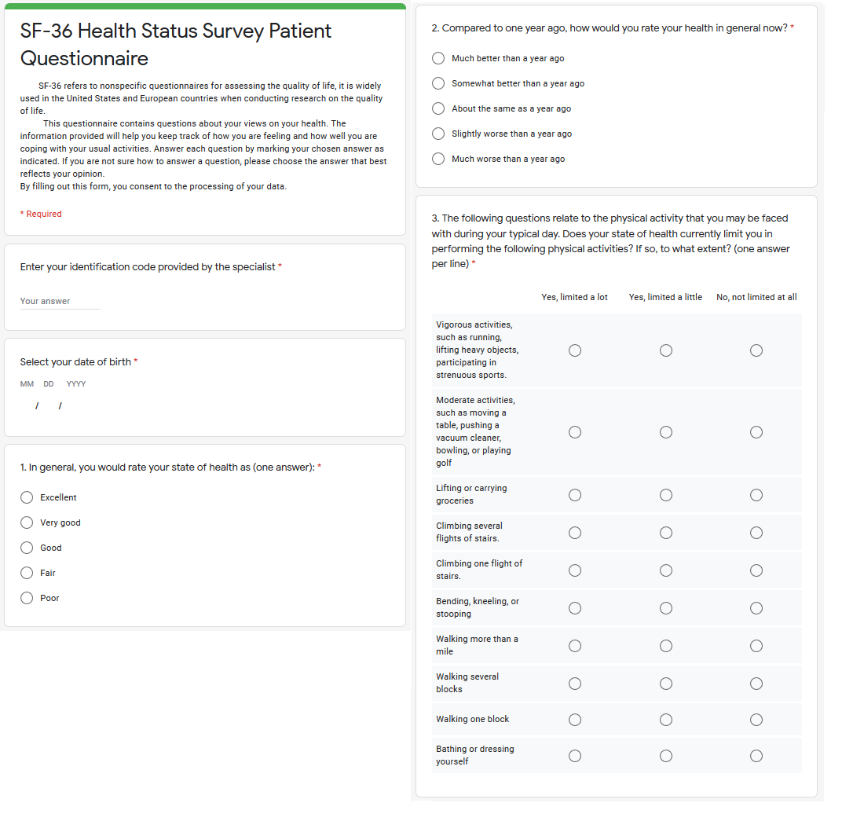
Questionnaire forms of SF-36 (modified from Ware JE, Kosinski M and Keller S, 1994)
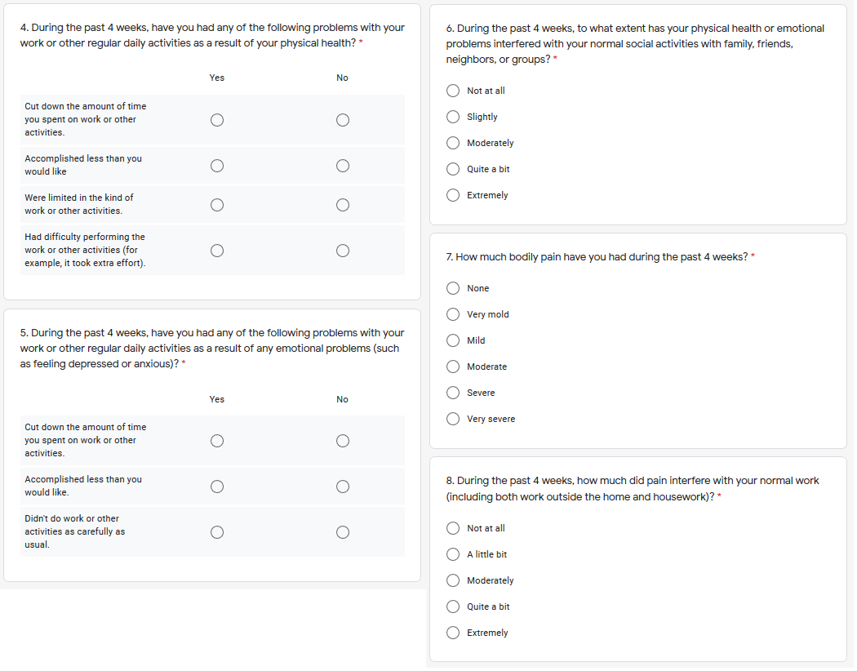
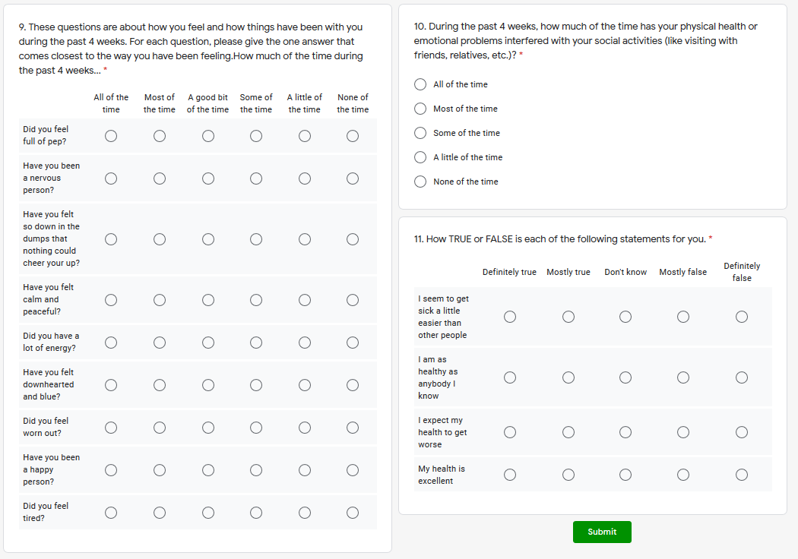

Supplementary References
[1] Temporary guidelines. Prevention, diagnosis and treatment of new coronavirus infection. 2020. Available at: https://www.garant.ru/products/ipo/prime/doc/73712452/ (Accessed: 2 September 2021).
[2] Methodological recommendations of the All-Russian public organization “Federation of anesthesiologists and resuscitators”. Anesthetic and resuscitation services for patients with the new coronavirus infection COVID-19. 2021. Available at: https://faronline.ru/api/static/cms-files/7e17aba2-57d5-40da-8553-f164ebe2f2dd/%D0%9C%D0%A0_%D0%A4%D0%90%D0%A0_covid-19_ver6_v07_for_website.pdf (Accessed 6 September 2021).
[3] Charlson ME, Pompei P, Ales KL, MacKenzie CR. A new method of classifying prognostic comorbidity in longitudinal studies: Development and validation. Journal of Chronic Diseases. 1987; 40: 373–383.
[4] Jenkinson C. The SF-36 physical and mental health summary measures: an example of how to interpret scores. The Journal of Health Services Research & Policy. 1998; 3: 92–96.
[5] Ware JE, Kosinski M, Keller SD. SF-36 physical and mental health summary scales: a user’s manual. 5th edn. Boston, MA: The Health Institute, New England Medical Center. 1994.

